

Bachelor of Computer Applications
Semester – V
Business Analytics
Experiment No.: 1
Title: Importing business datasets from flat files & MySQL and
connecting with any other sources into Power BI

Submitted By:
Name: G Surya Teja
Reg. No: 2411021240017
Date: 22-08-2026

Submitted To:
Faculty Name: Mr. Aman Kumar Sharma

Department of Computer Application
Alliance University
Chandapura - Anekal Main Road, Anekal
Bengaluru – 562106

Retail Sales Analytics – Data Integration and Dashboard Design
GitHub Link- https://github.com/suryateja-155/Business-Analysis-Projects/upload/main
Project focus: Using Power BI to combine retail information from structured sources, prepare it for analysis, and present the results through interactive business dashboards.

1. Project Overview
The project demonstrates a practical Business Analytics workflow in Power BI. Retail information covering products, customers, stores, and sales transactions is brought into a single reporting environment. Instead of examining individual records manually, the dashboard converts the data into KPIs and visual comparisons that can be interpreted quickly by a manager or analyst.

2. Data Preparation Approach
- Retail data was collected from structured business sources, including CSV/Excel-style files and a MySQLdatabase.
- Power BI's Get Data functionality was used to establish the required connections and load the tables.
- Power Query was used to review data types, remove unnecessary or duplicate information, and applytransformations.
- The prepared tables were organized into a model so that sales could be analyzed together with customer,product, store, and calendar information.

3. Dashboard Structure
The first dashboard page acts as an executive overview. It contains KPI cards for Total Sales, Total Quantity, Total Customers, and Total Orders, together with product-, city-, and category-level visualizations. Category and Month-Year slicers provide an interactive way to narrow the analysis.
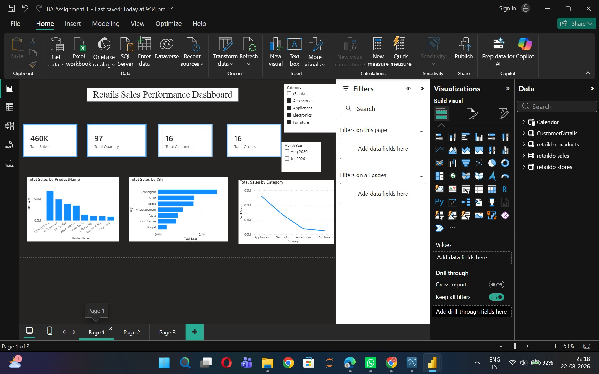
Figure 1. Power BI executive dashboard showing overall KPIs and sales comparisons by product, city, and category.

4. Initial Interpretation
The dashboard reports approximately 460K in total sales, 97 units of total quantity, 16 customers, and 16 orders. The product and category visuals make it possible to distinguish stronger contributors from lower contributors, while the city chart highlights differences in geographical sales performance.

Customer Behaviour and Payment Pattern Analysis
The second dashboard moves from overall business performance to customer-oriented analysis. It examines how sales vary by gender, payment method, age group, customer segment, and category-related values. This view is useful for understanding who contributes to revenue and how customers complete their purchases.

1. Gender-Based Sales Distribution
The donut chart divides total sales between male and female customers. The displayed values show approximately 59.8% of sales from male customers and 40.2% from female customers. The result suggests a higher contribution from male customers in the available dataset, while the female customer segment still represents a substantial share.

2. Payment Method Analysis
Credit Card is the leading payment method in the displayed dashboard, followed by Cash, UPI, Net Banking, and Debit Card. This comparison helps identify the payment channels most associated with sales value. Maintaining reliable digital payment options is therefore important for a smooth customer purchase experience.

3. Age Group and Customer Segment
The age-group visualization shows the 25–34 group as the strongest sales contributor, followed by the 35–44 group. The customer-segment chart indicates that Regular customers generate the highest sales, followed by Premium and New customers. Together, these visuals highlight the importance of both demographic targeting and customer retention.
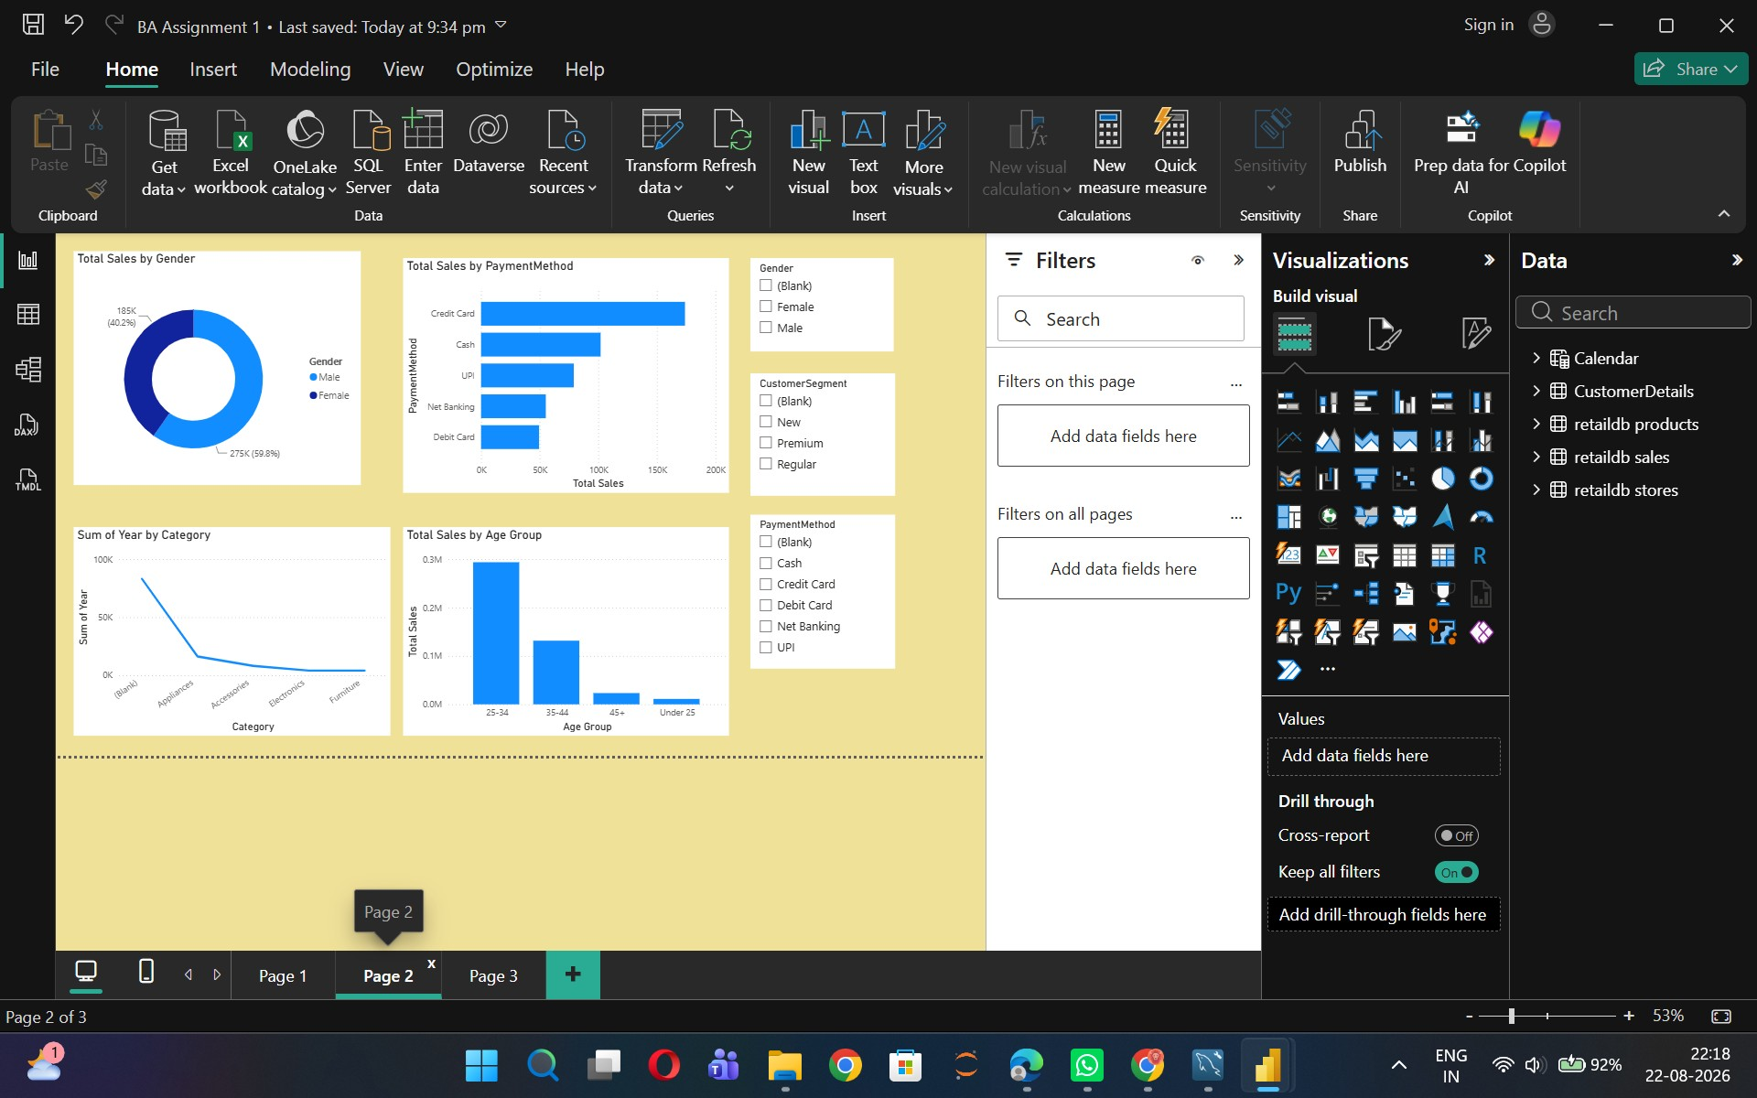
Figure 2. Customer analytics page with gender, payment-method, age-group, category, and customer-segment visuals.

4. Business Use of Customer Insights
- Target promotions toward the strongest age groups while maintaining relevant offers for other segments.
- Use loyalty initiatives to encourage New customers to become repeat customers.
- Monitor payment-method preferences and ensure that commonly used digital channels remain convenient.
- Compare category performance across customer groups to support more focused product recommendations.

Store Performance, Customer Value and Business Recommendations
The third dashboard provides a compact view of store format and customer-segment performance. It complements the earlier pages by showing how the retail network and customer groups contribute to orders and sales.

1. Store Type Comparison
The store-type pie chart compares Standalone and Mall stores. The dashboard displays 9 orders for Standalone stores and 7 orders for Mall stores, corresponding to approximately 56.25% and 43.75% of the displayed orders respectively. Both formats therefore contribute to the business, with Standalone stores showing a modest lead in order count.

2. Customer Segment Sales
The bar chart shows Regular customers as the largest contributor to sales, followed by Premium customers and then New customers. This pattern suggests that retaining existing customers can be an important part of maintaining stable revenue. At the same time, converting new customers into repeat buyers can create an opportunity for future growth.
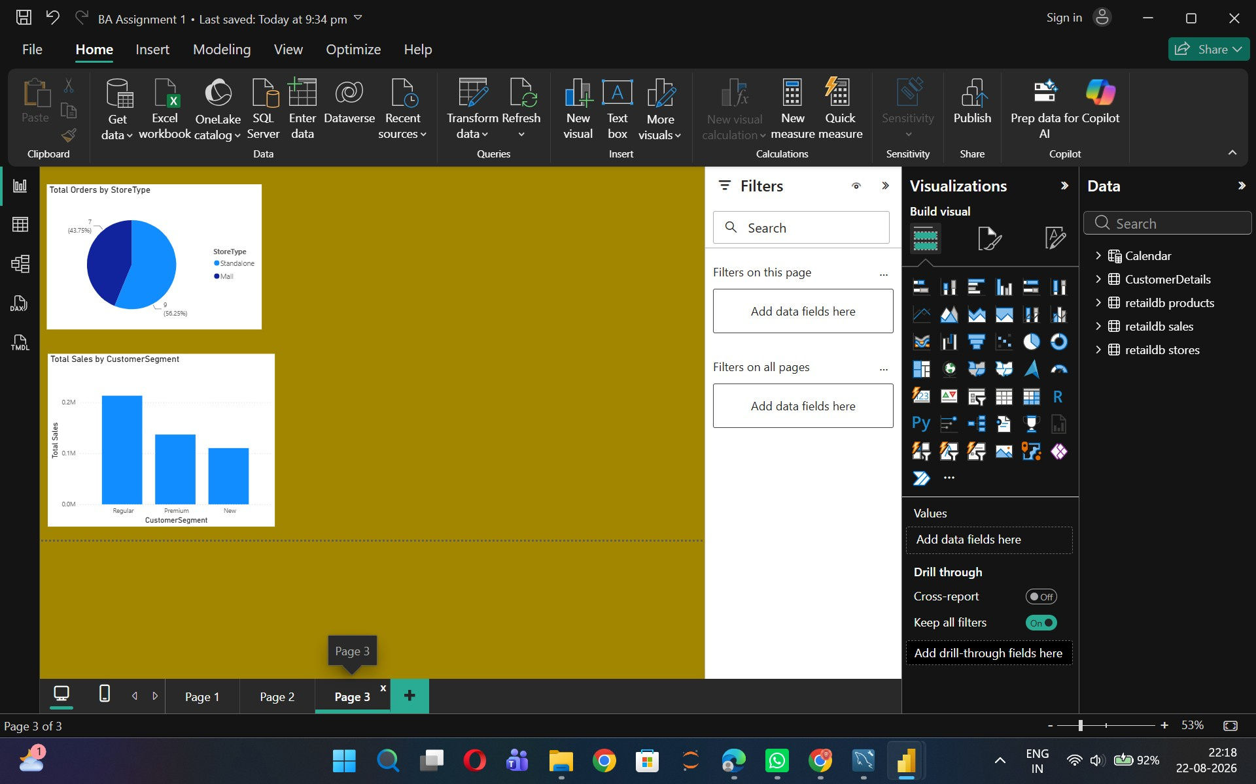
Figure 3. Store and customer-segment dashboard showing order distribution by store type and sales by customer segment.

3. Key Findings
- The dashboard provides a centralized view of retail performance rather than isolated data tables.
- Product, category, and city comparisons help identify areas of stronger and weaker sales contribution.
- Customer analysis shows meaningful differences by gender, age group, payment method, and segment.
- Regular customers are an important revenue source, making retention strategies relevant.
- Both Standalone and Mall stores contribute orders and should be evaluated using sales and profitabilitytogether.

4. Recommendations
Management can use the dashboard to prioritize high-performing products and categories, investigate lower-performing cities, design targeted campaigns for key customer groups, and strengthen customer-retention programs. The interactive slicers also allow users to examine the same metrics under different category and month-year selections, making the report useful for repeated monitoring.

5. Conclusion
The Power BI report demonstrates how data integration, transformation, modeling, and visualization can turn retail transaction data into actionable business information. The three dashboard pages provide complementary perspectives: overall sales performance, customer behaviour, and store/customer-segment performance. Together, they support faster interpretation and more informed retail decisions.

